# Software Requirements Specification (SRS) Dukaan

|  |  |
| --- | --- |
| **Course** | Software Engineering (SEMTZC344) |
| **Group** | 09 |
| **Project Title** | Dukaan |
| **Team** | Sinchana Shetty – 2023LM70047 |
|  | Saranya T – 2023LM70049 |
|  | John Mathew – 2023LM70050 |
|  | Zishan Alam – 2023LM70051 |
|  | Helen Jenifer – 2023LM70048 |

## Document Curated By:

|  |  |
| --- | --- |
| Created By | John Mathew – 2023LM70050 |
| Reviewed By | Sinchana Shetty – 2023LM70047 |

## Index

|  |  |  |
| --- | --- | --- |
| Index | Section | Page No. |
| 1 | Introduction | 3 |
| 1.1 | Purpose | 3 |
| 1.2 | Scope | 3 |
| 1.3 | Definitions, Acronyms, and Abbreviations | 3 |
| 2 | Overall Description | 3 |
| 2.1 | Product Perspective | 3 |
| 2.2 | Product Functions | 3 |
| 2.3 | User Classes and Characteristics | 3 |
| 2.4 | Stakeholder Needs and Pain Points | 4 |
| 3 | System Features | 5 |
| 3.1 | Functional Requirements | 5 |
| 3.2 | Non-Functional Requirements | 5 |
| 4 | Data Model | 6 |
| 4.1 | Entity Descriptions | 6 |
| 5 | UML and System Diagrams | 7 |

## 1. Introduction

### 1.1 Purpose

Dukaan is a hyperlocal e-commerce platform that connects users with nearby vendors, allowing them to browse, compare, and purchase items at local prices. It aims to decentralize the supply chain, promote local commerce, and support sustainable urban development.

### 1.2 Scope

* The application enables:
* Users to explore nearby shops.
* Price comparison across vendors.
* Real-time stock visibility.
* Local delivery by area-based partners.
* Vendor inclusion from local and super marts.

### 1.3 Definitions, Acronyms, and Abbreviations

* SDG 11: Sustainable Development Goal 11 – Sustainable Cities and Communities.
* ER Diagram: Entity-Relationship Diagram.
* CRUD: Create, Read, Update, Delete operations.

## 2. Overall Description

### 2.1 Product Perspective

Dukaan is similar to platforms like Blinkit and Zepto but also focuses on local vendor integration and price transparency.

### 2.2 Product Functions

* User registration and login
* Vendor registration and item listing
* Item search, filtering, and comparison
* Order placement and live tracking
* Delivery assignment and review system
* Admin analytics dashboard

### 2.3 User Classes and Characteristics

* Customer: Browses items, places orders, tracks deliveries.
* Vendor: Lists items, manages stock and prices.
* Delivery Partner: Fulfills deliveries and receives ratings.
* Admin: Manages users, vendors, deliveries, and analytics.

## 2.4 Stakeholder Needs and Pain Points Summary

* Customer: Difficulty locating nearby vendors, inconsistent pricing, and slow delivery.
* Vendor: Complex registration and manual stock management.
* Delivery Partner: Lack of real-time info and rating visibility.

|  |  |  |
| --- | --- | --- |
| Stakeholder | Pain Point / Feedback | System Requirement |
| Customer | Difficulty finding shops | Geolocation-based shop discovery |
| Customer | Price varies by store | Price comparison across vendors |
| Customer | Late/no delivery info | Live delivery tracking |
| Customer | Product unavailability | Real-time stock info |
| Vendor | Registration complexity | Simple onboarding |
| Vendor | Stock management issues | Inventory dashboard |
| Vendor | No sales analytics | Dashboard with insights |
| Delivery | No route guidance | Navigation & live order mapping |
| All | Communication friction | In-app notifications & chat |

## 3. System Features

## 3.1 Functional Requirements

## For Customers

## Shop Discovery: Locate nearby shops using device geolocation.

## Product Listing & Filtering: Browse and filter products by category, price, availability.

## Price Comparison: Compare product prices across different shops.

## Order Placement: Add items to cart, checkout, select delivery options.

## Order Tracking: Live map-based tracking after order is placed.

## Favorites: Mark items/shops for quick future orders.

## Multiple Payment Options: Cash, UPI, card.

## For Vendors (Shopkeepers)

## Vendor Registration: Simple signup & onboarding.

## Product Management: Add/edit/delete items, manage inventory and pricing.

## Order Management: View/manage orders, update order status.

## Sales Insights: Dashboard for sales, popular items, customer behavior.

## Stock Alerts: Real-time notifications when inventory is low or orders arrive.

## For Delivery Partners

## Order Assignment: Auto-assignment and manual order selection with map filtering.

## Navigation: Integrated map and address details for pickup and delivery.

## Live Status Updates: Update customer/vendor on progress.

## Earnings & History: Track daily earnings, order completion stats.

## For Admin

## User & Vendor Management: Approve or suspend accounts.

## Analytics: View platform-wide metrics (orders, revenue, complaints).

## System Maintenance: Manage platform settings and resolve reports.

## 3.2 Non-Functional Requirements

## Performance: All regular operations (search, add to cart, order status) under 2 seconds.

## Scalability: Should handle city-wide simultaneous users.

## Reliability/Availability: 99.5% uptime.

## Security: All user payments and data encrypted; role-based access.

## Usability: Simple, minimalist interface for customers; detailed/advanced dashboard for vendors.

## 4. Data Model

### 4.1 Entity Descriptions

**1. Customer**

* **CustID** *(PK)*
* Name
* Address

**2. Vendors**

* **VendID** *(PK)*
* Vendname
* Address

**3. Item**

* **ItemID** *(PK)*
* Itemname
* Price
* **CategaryID** *(FK → Categary.CategaryID)*

**4. Orders**

* **OrderID** *(PK)*
* **CustID** *(FK → Customer.CustID)*
* **VendID** *(FK → Vendors.VendID)*
* **ItemID** *(FK → Item.ItemID)*
* Quantity
* Price

**5. Delivery**

* **DeliveryID** *(PK)*
* **OrderID** *(FK → Orders.OrderID)*
* **DelServID** *(FK → DeliveryServ.DelServID)*

**6. Categary**

* **CategaryID** *(PK)*
* Categaryname

**7. DeliveryServ**

* **DelServID** *(PK)*
* Name

# 5. UML and System Diagrams

# Use Case Diagram

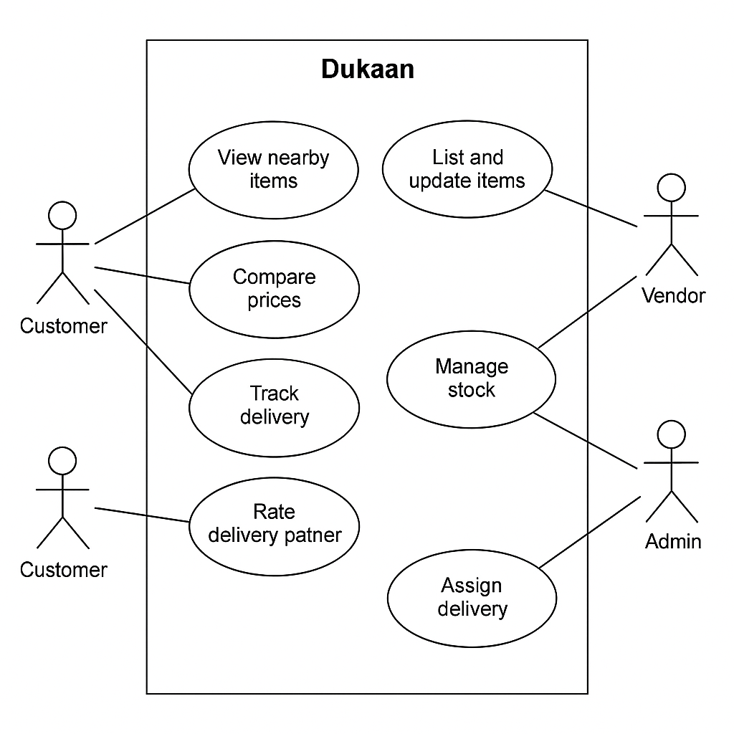

## Activity Diagram

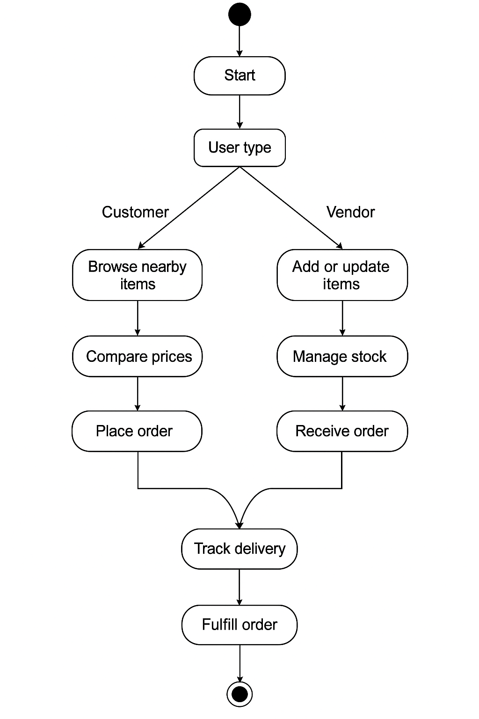

## State Machine Diagram

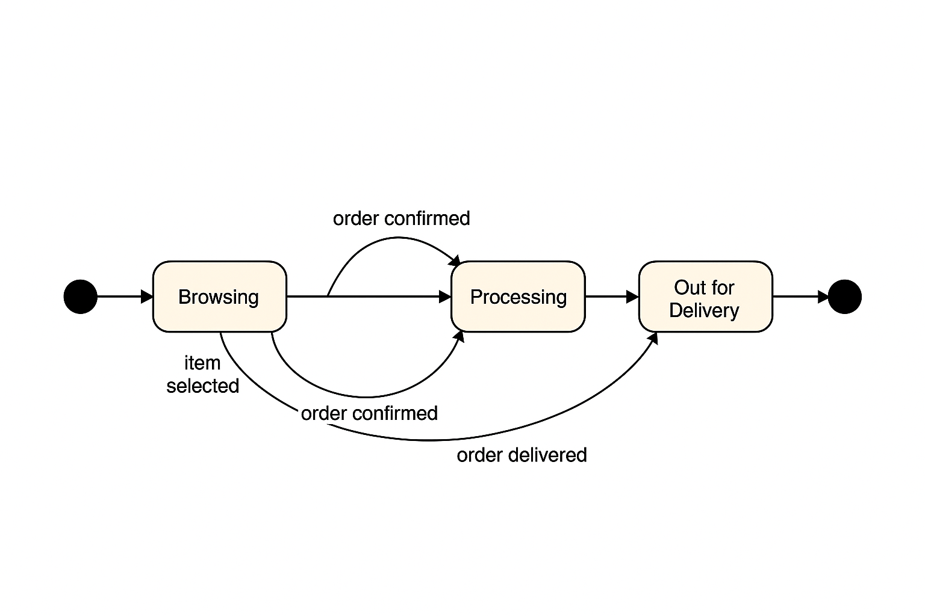

## Sequence Diagram

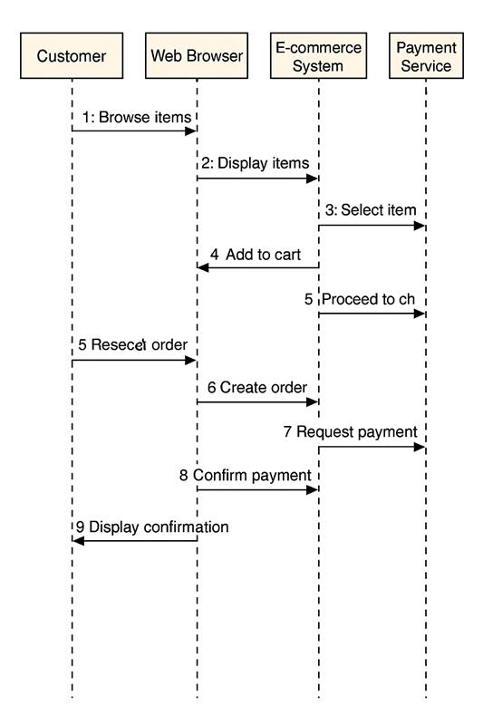

## Data Modelling

## Class Diagram

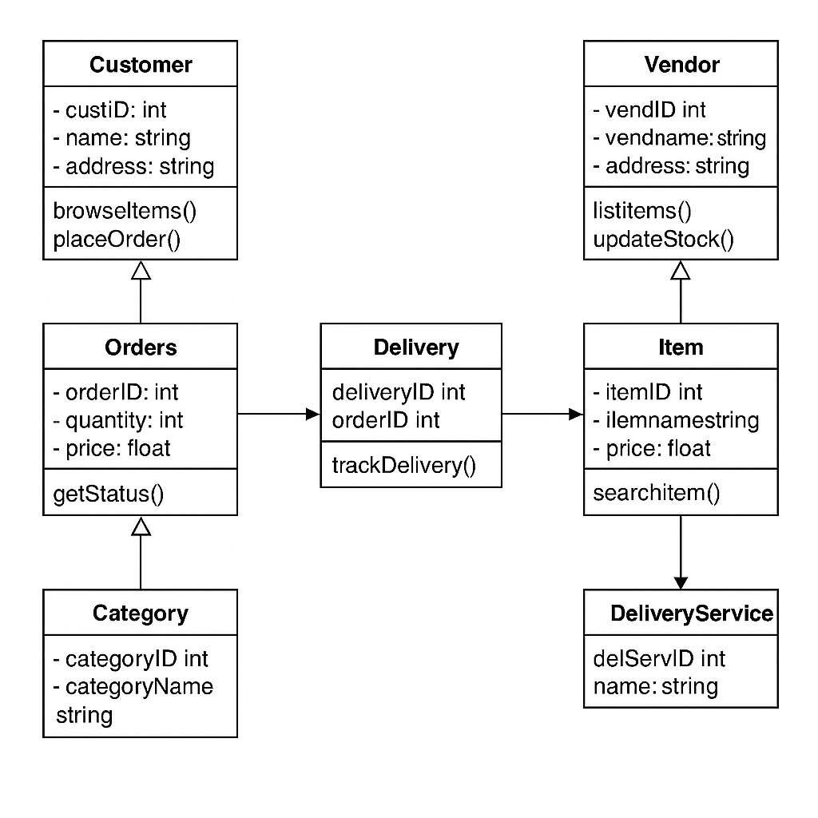

## Component Diagram

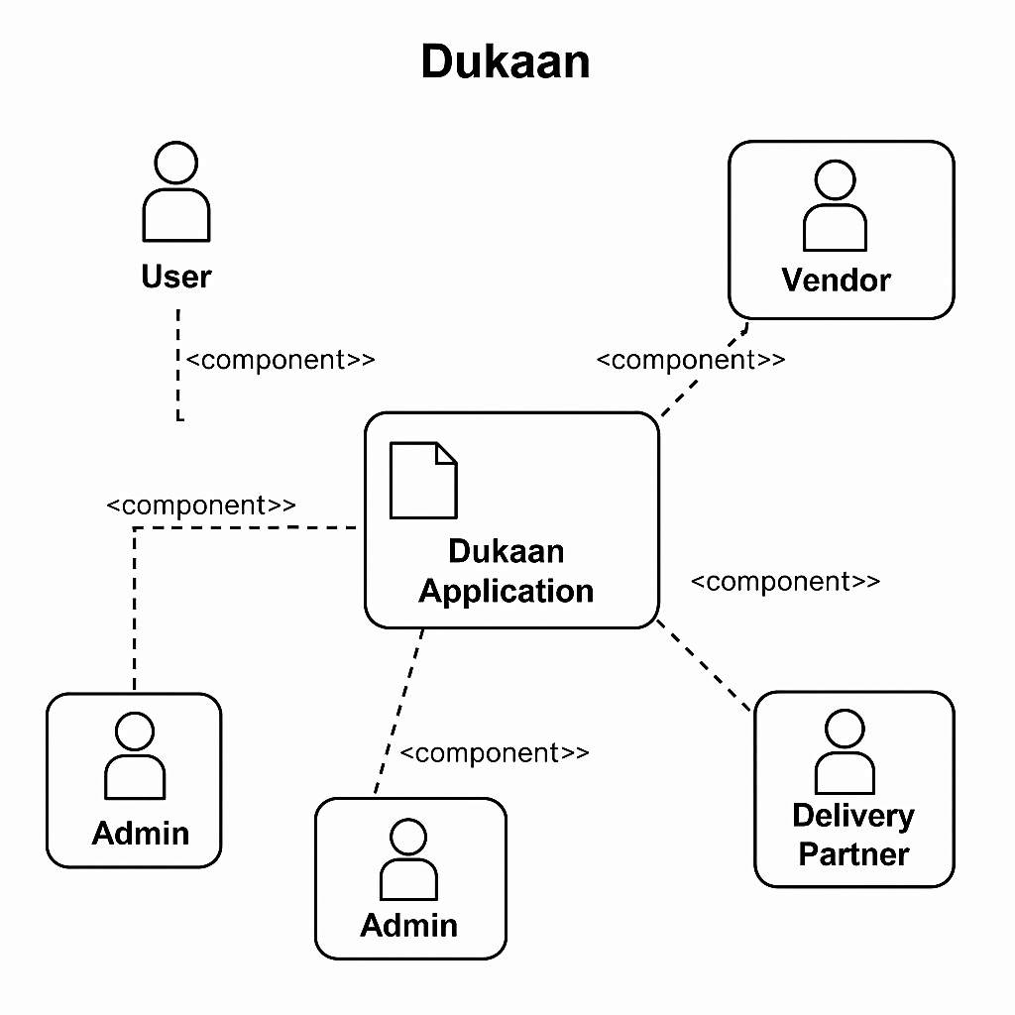

## Deployment Diagram

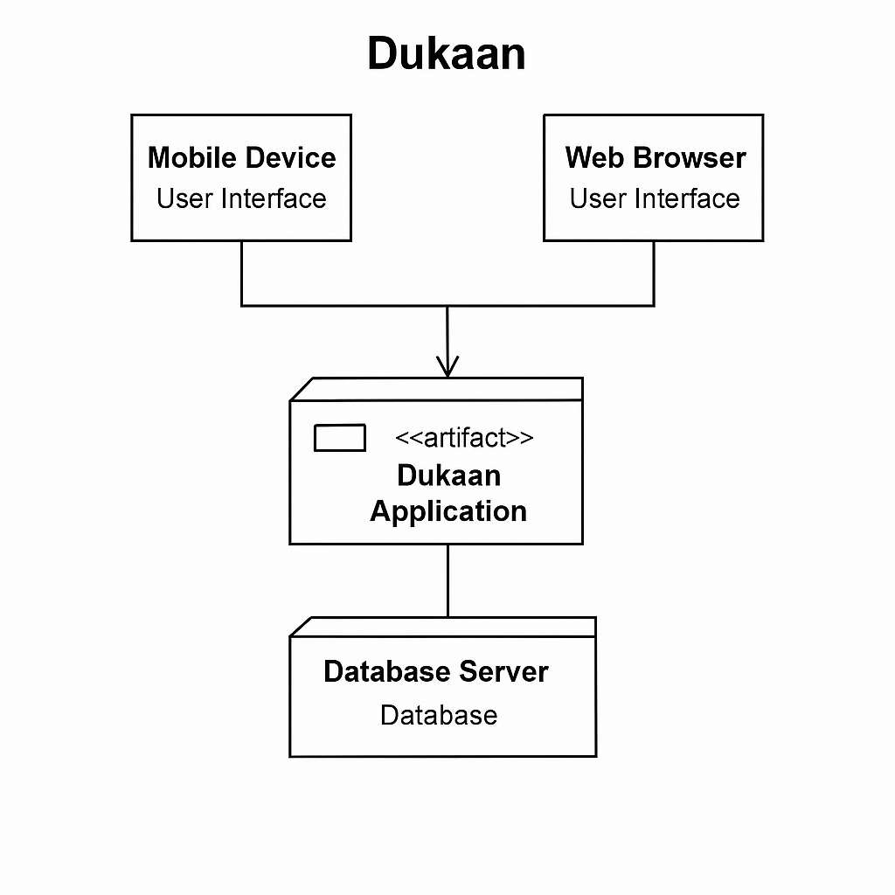

## Two levels of Data Flow Diagram

## 0 level Data Flow Diagram

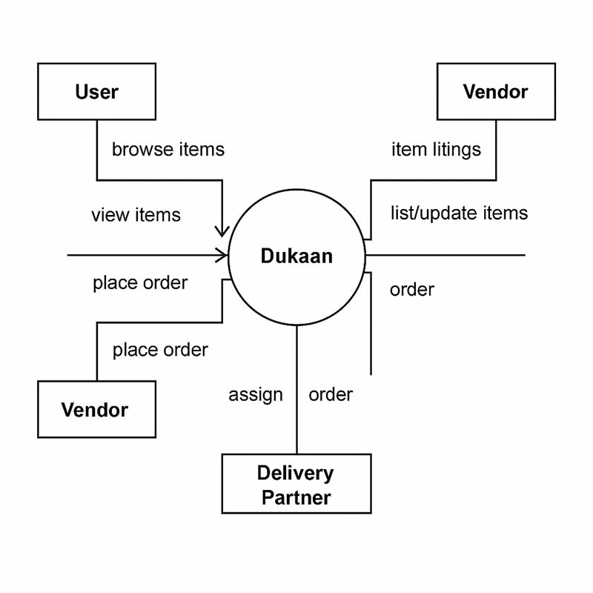

## 1 level Data Flow Diagram

